# India

India, a vibrant mosaic of cultures, traditions, and innovations, is home to cities that are rapidly transforming into global technology hubs. Three major IT Hubs are considered in this report.

**Pune**, with its rich historical heritage, now thrives as an educational and IT powerhouse, attracting students and professionals alike.

**Bangalore**, often dubbed the "Silicon Valley of India," stands at the forefront of the country's tech industry, housing numerous startups, tech giants, and research institutions.

**Hyderabad** merges its majestic past with a dynamic present, boasting a booming IT sector alongside its famed biryani and historic landmarks.

These cities, in their evolution from historic centers to modern tech cities, collectively underscore India's pivotal role in the global digital economy, fostering innovation, technology, and entrepreneurship as the country journeys toward becoming a leading player in the global technological landscape.

## Executive Summary

### Talent:

#### Talent Availability:

- Talent is generally available across all considered locations, with predominantly positive reviews for each.

- Competing with international companies in IT hubs is necessary to attract the best talent, particularly for senior role

#### Attrition Management:

Each location will require a tailored incentivization plan, such as offering competitive salaries and benefits or opportunities for professional development, to effectively manage attrition rates.

### Cost:

#### Cost Analysis:

- The highest cost savings are observed when hiring for junior roles, though each ODC should start with hiring senior people first to set up the correct foundations for the new center. Over a period of time you should have a good mix of experiences.

## Operations:

### ODC Operationalization:

## - Establishing an ODC typically takes between 6 months to 1 year, with cost benefits expected to become visible within a quarter of establishment.

- India requires a minimum of two Indian citizen directors, one of which should be a resident Indian.

## Success Recipe: Champion Selection:

## - Success in ODC implementation necessitates sending a dedicated champion rather than solely relying on outsourcing to recruitment agencies.

## Typical ODC Models

### Setting up legal entity

Outsource Model: Independent company that can recruit and build a dedicated Pod with the intent to transfer the team after a year or so

**Subsidiary Model** : Fully owned subsidiary with India-based management

* Legal costs: $4-5K; Time: 45 - 60 days
* Ownership: No restrictions on who owns the entity • Indians OR foreigners OR Expats
* Directors: Three directors preferred with 2 resident in India
  + Could be foreigner/ residents of India for faster board approvals and regulatory filing

**Transfer Price (TP) Model:** A common business model between US and India subsidiary

* The parent company typically pays the total cost of operations plus 20% (recommended domestic profit)**.**
* The subsidiary company pays corporate taxes, which are applicable to the TP profit in India.
* The profit after taxes (PAT) may be used for incentivizing key people and building up capital for future expansion.

**Liaison Office Model:**

* Legal costs: $1K; Time: 45 - 60 days
* It acts as a representation of foreign establishments in India.
* Promotion of imports and exports.
* Exploring the business conditions.
* Understanding the nature of the Indian Market.
* To Enhance Goodwill by maintaining, bringing foreign Technology into India.
* Establish healthy communication Between the foreign principals and the parties with the motive to create market opportunities.

## Operation Model

* **Centralized**: India senior management has direct interface with HQ and they, in turn, manage the team's day-to-day activities based on inputs from the HQ
  + Centralized operation model may be better suited for managed services and support functions
* **Decentralized**: India technical team has direct connect with their counterparts and India management's role is to that of ensuring that the technical team has no roadblocks
  + Decentralized operation model is better suited for new product/ service initiatives where the specs may be changing or where a lot of interaction with the HQ is needed on a frequent basis.

## IT Salary

* India IT salary has literally gone through the roof over the past 10 years • India salary hike has been averaging at 12-15% per year for the past 10 years
  + Average salary of software developer has increased 2- 4x since 2015
* Very difficult to move developers with niche skills without really attractive offers or an attractive incentive plan
* Typical "notice period" is 90 days, so boarding would take at least 120 days. Notice Period – Mandatory time between resignation and exit dates
* Recent slowdown in the US has made senior developers somewhat risk averse because of fear of startup shutting down
* Loaded labor rate (LLR) is generally 50% more than the salary + incentive cost
* ***Best ways to manage the overall cost***
  + Invest in training junior developers, who initially shadow the project and then they are assigned tasks
  + Replace contractors as soon as a replacement has been found.

### Current Salary Levels

Bangalore - Data Set 1

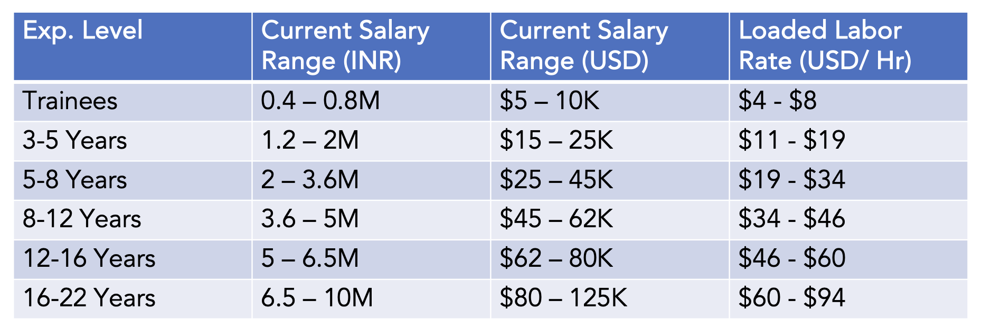

India average ( source xto10x report)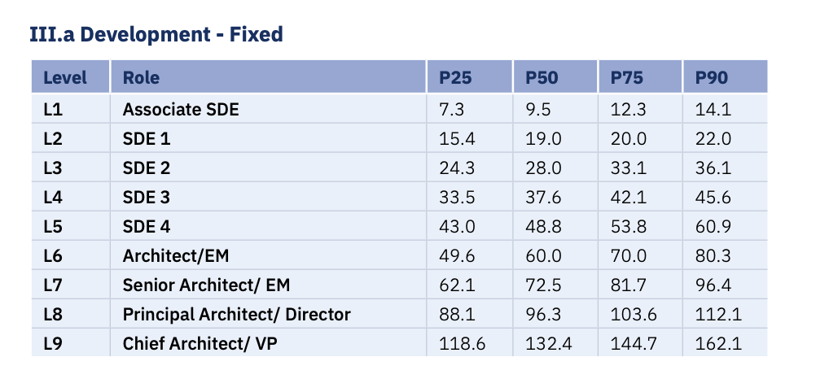

## Talent Pool

* Talent pool availability is extremely high in any city of India. Java tech stack is widely used.
* Companies might struggle to find talent for design and Front end stack but recent reports suggest that this skill set is also on the rise. Most companies offer training to upskill their staff.
* There are multiple government aided/supported agencies such as CDAC which routinely produce thousands of capable programmers and managers.
* Attrition is high in all IT hubs especially in the 5-12 year experience range. The ranges hovers around 1.5 years

## Real Estate Costs

Real estate costs vary with the city and location of the office. This is inline with any other IT hubs in the world.

Here is a high level estimate from one Data set available to me. I have not considered cities like Mumbai due to high costs but leaving the data here for comparison.

**Summary** - The rental costs hover between 74 - 137 Rs/Sqft ( i.e $0.9 to $1.3) . For 15-20 employees we are looking at 5000 sq ft of space.

| **City** |  | **Desk / Month** | **# 15 Seats** | **Lease Agreement (Approx 80% of Weworks )** | **USD** |
| --- | --- | --- | --- | --- | --- |
|  |  |  |  |  |  |
| Mumbai | Andheri-East | 24000 | 360000 | 288000 | 3471 |
|  | Goregaon-Nesco | 32000 | 480000 | 384000 | 4628 |
|  | BKC | 45000 | 675000 | 540000 | 6507 |
|  |  |  |  |  |  |
| Bangalore |  |  |  |  |  |
|  | Koramangala | 21000 | 315000 | 252000 | 3037 |
|  | MG Road | 26000 | 390000 | 312000 | 3760 |
|  | Infantry Road | 27500 | 412500 | 330000 | 3977 |
|  |  |  |  |  |  |
| Pune |  |  |  |  |  |
|  | Magarpatta | 19000 | 285000 | 228000 | 2748 |
|  | Kalyani Nagar | 20000 | 300000 | 240000 | 2892 |
|  | Kharadi | 21500 | 322500 | 258000 | 3109 |
|  |  |  |  |  |  |
| Hyderabad | |  |  |  |  |
|  | Kondapur | 17000 | 255000 | 204000 | 2458 |
|  | Financial District | 19000 | 285000 | 228000 | 2748 |
|  | Madhavpur | 21500 | 322500 | 258000 | 3109 |

## Pune Mumbai

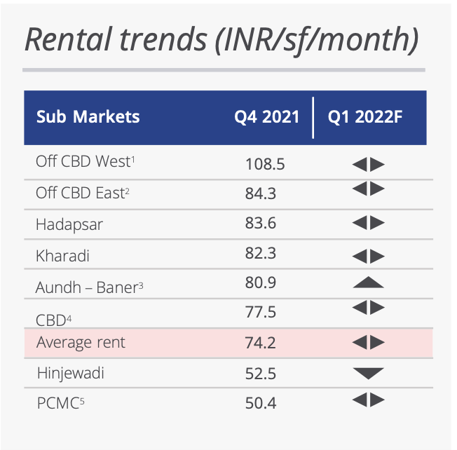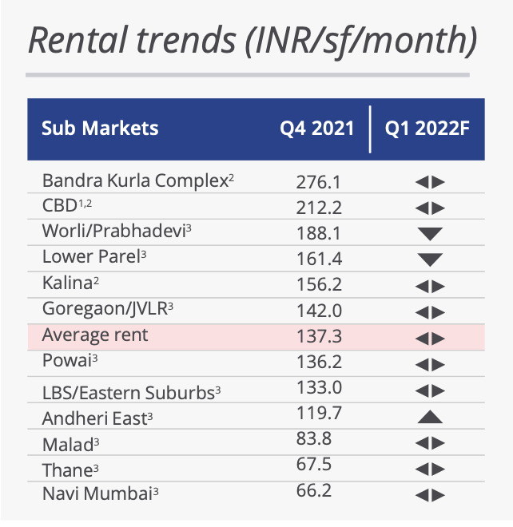

Bangalore

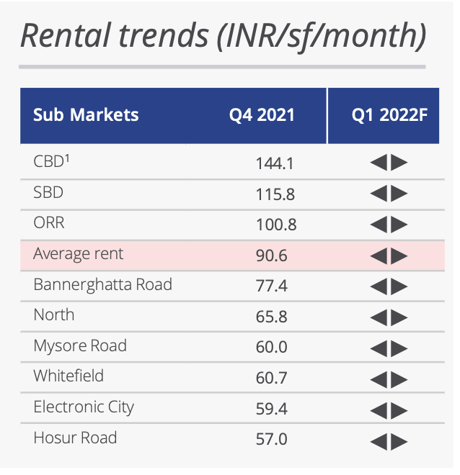

## FAQ

* **What would be expected savings in the cost with this center**

If you were to hire a mix of engineers, IT, security, support, integration, and other related functions, the savings on a three-year horizon could be anywhere between 30–40% of the cost of hiring in a European city such as London. The actual savings is dependent on the choice of city and mode of operation.

* **What are some of the concerns to be aware of while opening this center**

You will need to set up management, HR and other support functions for this center without which it’s difficult to get cohesion and productivity. Attrition rates are high in India, especially in the 5–8 year experience range, and it would require experienced management to govern and control the movement.

* **How is country stability, infrastructure and other factors which can have an impact on productivity and operations?**

All IT hubs in India are well-established and have been vetted by major international companies, with most having offices there. Some cities, such as Bangalore, are now experiencing growing pains with traffic congestion and high real estate prices. Other cities, like Hyderabad and Pune, are attracting businesses seeking to avoid those issues.

* **How about operational challenges, timezone and culture**

Setting up the right culture should not be a problem as most senior engineers and management personnel have experience working with International countries.

* **Quality of Engineers**

India occupies the top spot for offshore [development centers across the world.](https://outsourcinginsight.com/the-ultimate-guide-to-offshore-development-centers/) 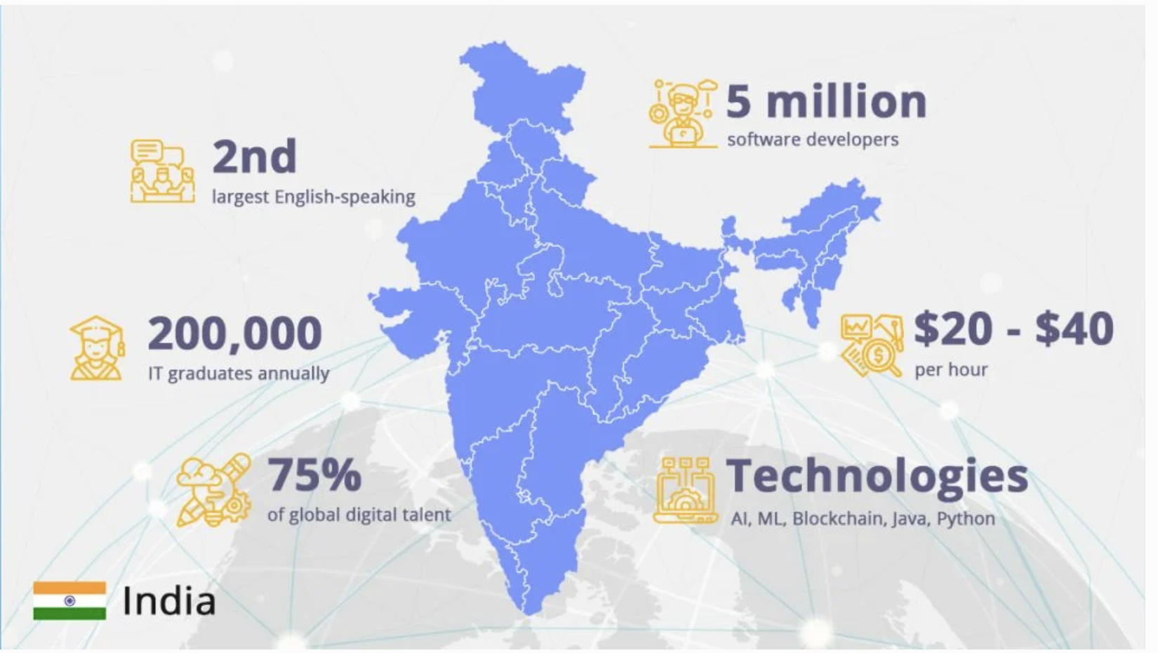

With Poland as close second

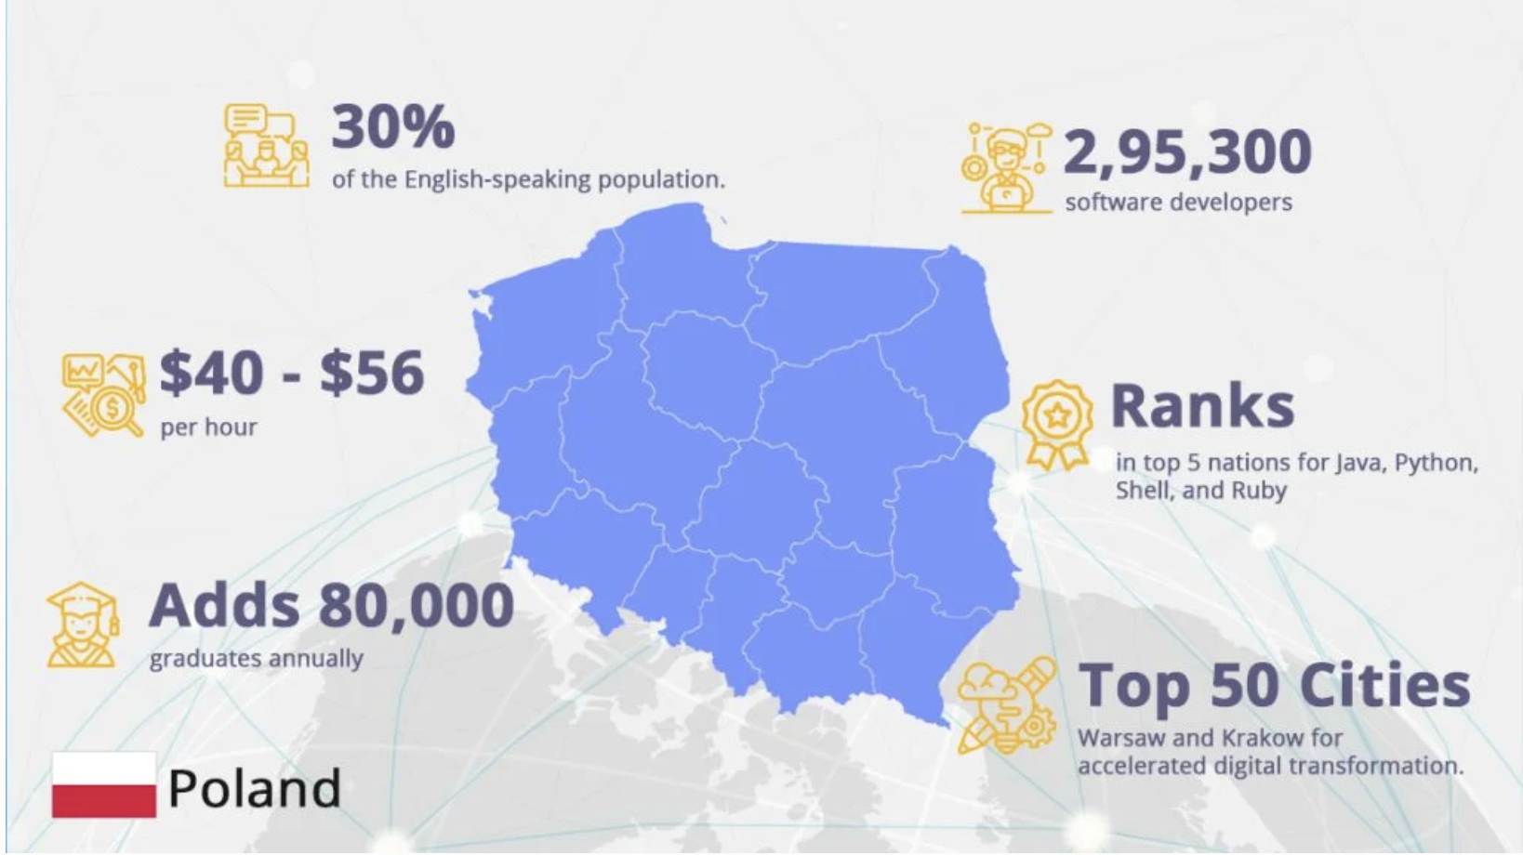

* **How does attrition rate (tenure) compares with other markets**

Attrition rates in India are around 15-20% which aligns with the IT industry standard of 18-22%. Some companies are able to keep the rate below 15% using benefits and various other methods for compensation.

# References and Helpful Links

Taxation comparison : <https://taxsummaries.pwc.com/compare-territories?compare=98300693-e570-4fae-ad66-304af88c040d,59d20577-65f8-4c9d-8a8f-6b56a9189229,40103ec2-e144-4660-8bea-398c76271176,7c90c2b5-2720-43e8-9245-067b0d2a4319,08d05275-0303-44ab-815b-9bc180e80acb>

Attrition Rate India

<https://www.financialexpress.com/business/industry-it-engineering-firms-continue-to-faces-high-attrition-3307095/>

<https://www.yourteaminindia.com/blog/countries-to-setup-offshore-development-center#:~:text=India%2C%20Ukraine%2C%20China%2C%20Mexico,environment%2C%20and%20cost%2Deffectiveness>.